Tub Maintenance

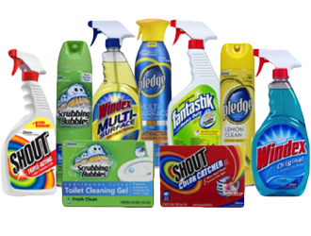
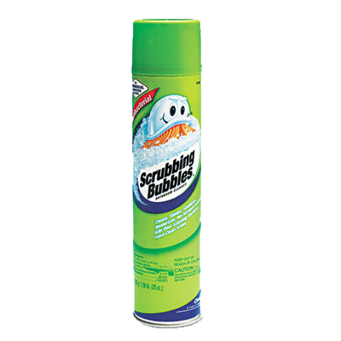
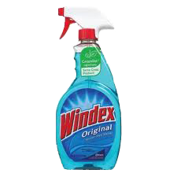

Follow these simple suggestions to maintain your newly refinished tub looking great!
Due to the non -porous surface of the finish, there is no need to use abrasive cleansers. Any house hold liquid detergent will give excellent results.
- DO NOT use the surface for 24 hours from the date of application.
- DO NOT lay soap or bottles or any objects on the finish at any time.
- DO NOT use abrasive cleaners. NO S.O.S pads NO COMET NO AJAX
- DO NOT use loose bath mats with suction cups
- Leakey fixtures must be repaired ASAP
- Any surface dust will dissipate in 3-4 weeks with normal cleaning and usage. DO NOT pick surface dust off with finger.
- Caulk around the tub before using.
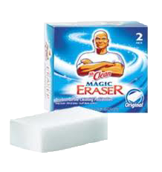
- Best way to keep tub clean … wipe it down with a towel after every use. (you don’t have to wipe it dry)
